Welcome to Galactic Roam

**DEBRIEF**

**GOAL: Survive as long as possible**

**No “HULL STRENGTH” will result in *GameOver*.**

**Roam around as long as possible, destroy any enemy ships (CHOOSE COLOR) and collect as much valuable debris as possible and build up your space craft to be the most feared vessel in the sector.**

**TODO: ADD ANY ADDITIONAL INFORMATION HERE**

**Movement: WASD**

**UseWeapon: HOLD LEFT MOUSE BUTTON(in desired direction)**

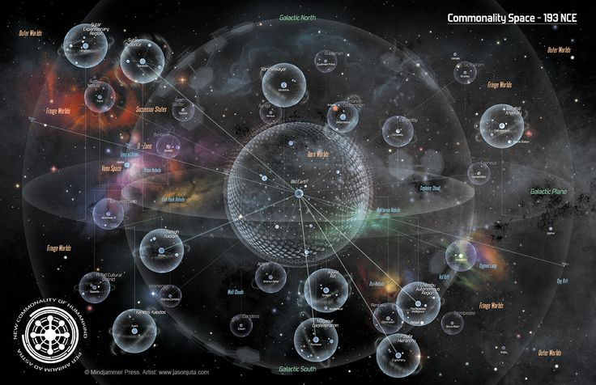**Game Mechanics: Components of ships may fly off when they become too damage to remain attached to the hull, these components will automatically attach to vessels that are within range, use the *SMOOTH* movement mechanics to strategically maneuver and take damage on less valuable components and avoid losing the equipment that best aid in your survival.**

[Type a quote from the document or the summary of an interesting point. You can position the text box anywhere in the document. Use the Text Box Tools tab to change the formatting of the pull quote text box.]

‘SPACE’ TO CONTINUE

‘ESC’ TO SKIP HELP